Inverter and NAND Using CMOS
Introduction:
MOSFET stands for Metal Oxide Semiconductor Field Effect Transistor. It is used to implement different analog and digital circuits. Today, I will be using it to create a NOT gate (Inverter) and NAND gate. NAND gate and NOR gate are complementary CMOS gates.

NOT Gate:
Input | Output
0 | 1
1 | 0

Circuit Diagram:
This simulation is performed on LTSpice.
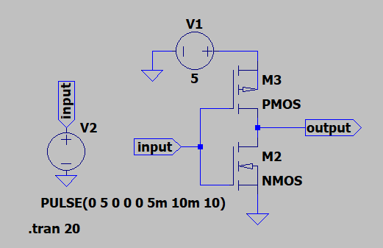

Simulation Result:
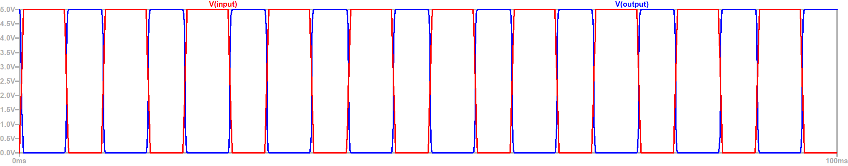
Input logic voltage is provided to gate of pMOS and nMOS. A pulse is provided with time period of 10ms with 50% duty cycle. When input pulse goes high, the pMOS turns off and nMOS turns on and pulls down the output, hence output goes low. When input pulse goes low nMOS turns off and pMOS pulls up the circuit to logic high.

NAND Gate:
Input A | Input B | Output
0 | 0 | 1
0 | 1 | 1
1 | 0 | 1
1 | 1 | 0

Circuit Diagram:
This simulation is performed on LTSpice.
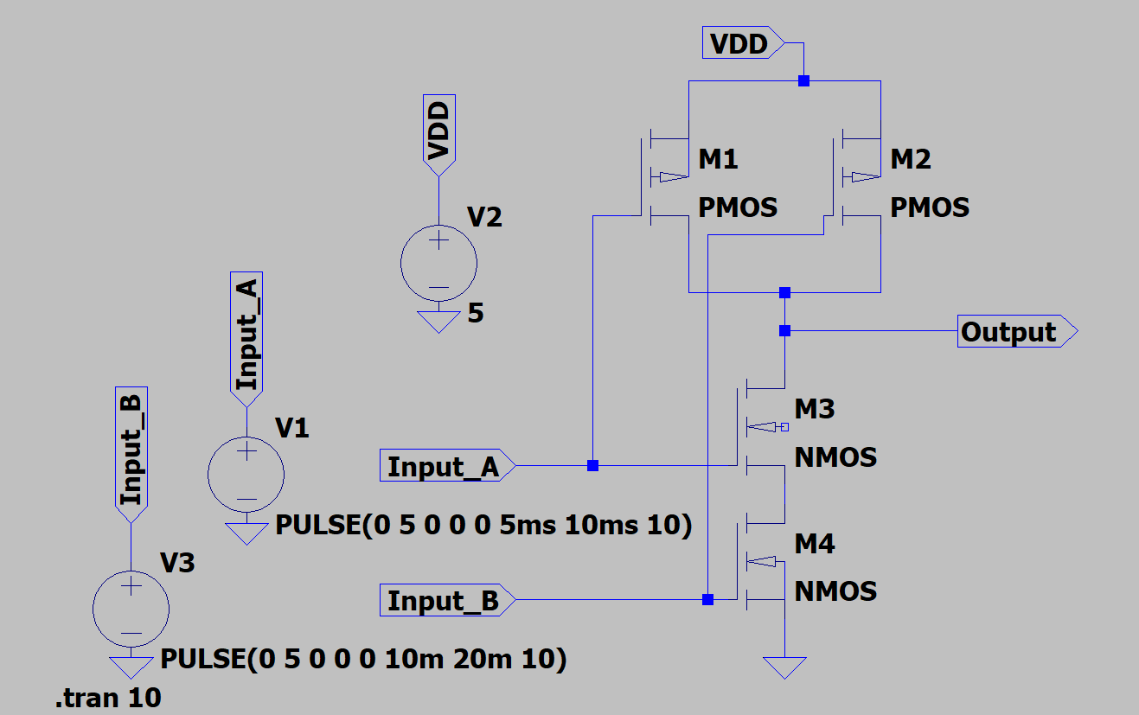
Input_A is a pulse with time period of 10ms and 50% duty cycle.
Input_B is a pulse with time period of 20ms and 50% duty cycle.

Simulation Result:
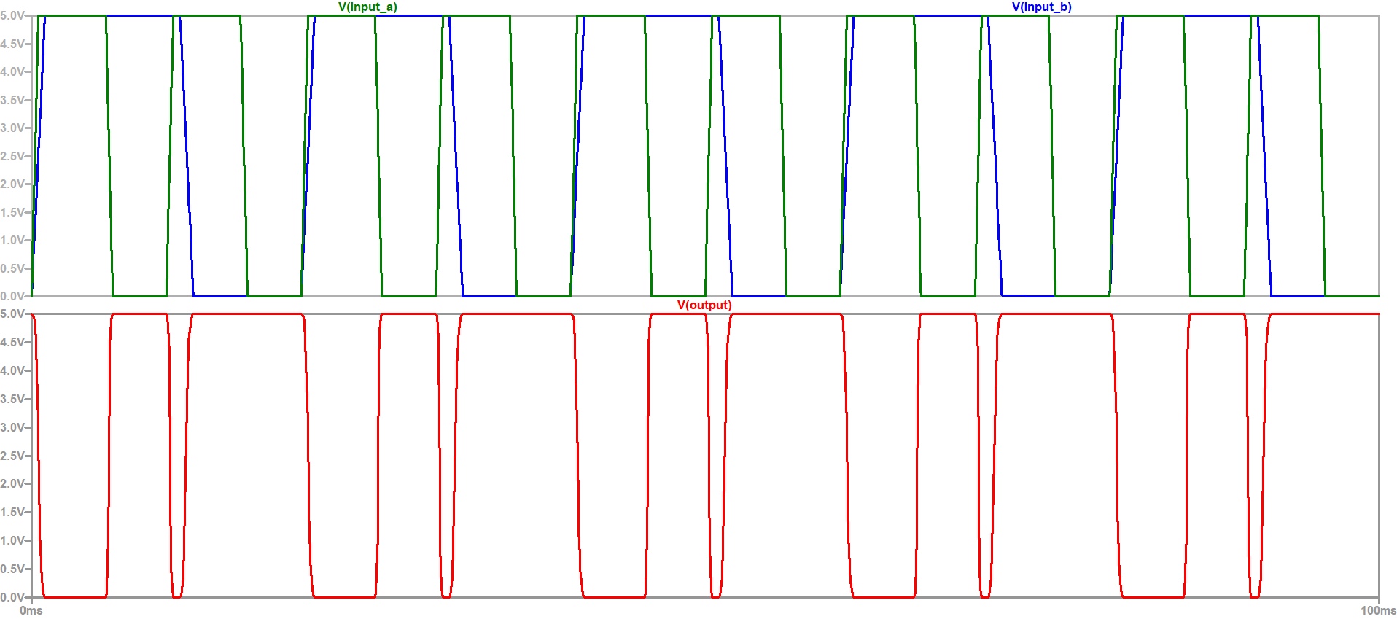

The parallel pMOS network forms a pull up network for the output and the series nMOS network forms a pull down network for the output. If any of the pMOS is ON the output is pulled up to logic HIGH and only and only if all the nMOS are turned on then the output is pulled down to logic LOW.

Author:
MADHUSUDAN

